**Table of Contents**

Introduction……………………………………………………………………………… 2

Equipment ………………………………………………………………………………. 3

Procedure………………………………………………………………………………… 4

1. Proportional Controller ………………………………………………………….. 4
   1. Part a) ……………………………………………………………………….. 4
   2. Part b) ……………………………………………………………………….. 4
   3. Part c) ……………………………………………………………………….. 5
2. Integral Controller ……………………………………………………………….. 6
   1. Part a) ………………………………………………………………………... 6
   2. Part b) ………………………………………………………………………… 7
   3. Part c) ………………………………………………………………………… 8
3. Proportional Integral Controller …………………………………………………... 8
   1. Part a) ………………………………………………………………………… 8
   2. Part b) ………………………………………………………………………… 9
   3. Part c) …………………………………………………………………………10

Analysis …………………………………………………………………………………... 11

Conclusion ………………………………………………………………………………... 15

Appendix A ……………………………………………………………………………… 16

Appendix B ……………………………………………………………………………… 17

Appendix C ……………………………………………………………………………… 19

**INTRODUCTION**

In the following work a study of the transitory response of a plant and its transfer function for different proportional, integral and proportional integral controllers will be carried out. The transitory response of said controllers will be analyzed by varying the parameters that define them.

The stabilization times and the final values of the error for the plant will be analyzed. In addition, using a routine in MATLAB will analyze the disturbance rejection for each controller and determine which parameters offer a better response. On the other hand, a model will be created in Simulink to study the separate response of each controller, using the block diagram.

Based on the answers that are obtained, it will be determined which controller is the one indicated to control the plant.

**EQUIPMENT**

The following equipment was used in order to perform the analysis of the plant.

* Pencil and paper.
* Calculator
* Computer
* MATLAB R2014B with Simulink

**PROCEDURE**

The Transfer Function of the plant will be represented in the Simulink models as:

$$G\left(s\right)=\frac{2}{(s+1)(s+3)}=\frac{2}{s^{2}+4s+3}$$

1. **Proportional Controller**
2. Draw a block diagram to represent the unity feedback control system when plant is controlled by a cascade proportional controller.

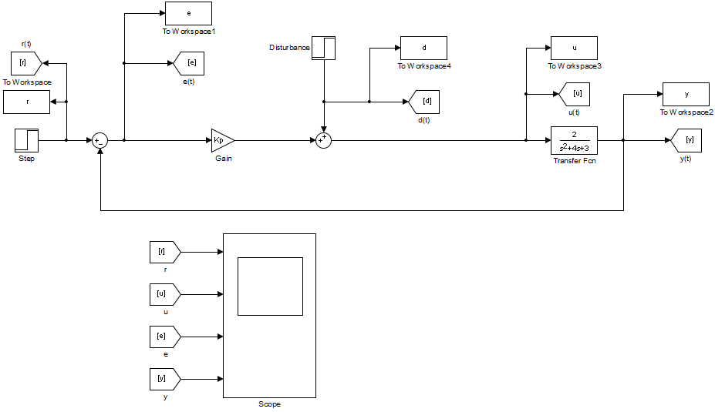

Figure 1.1. Proportional Controller Model.

1. The following figures represents the system response using a Proportional Controller with different gain values and no disturbance, setting the System Input as a unit step. These figures were obtained using a MATLAB routine, found in Appendix A.

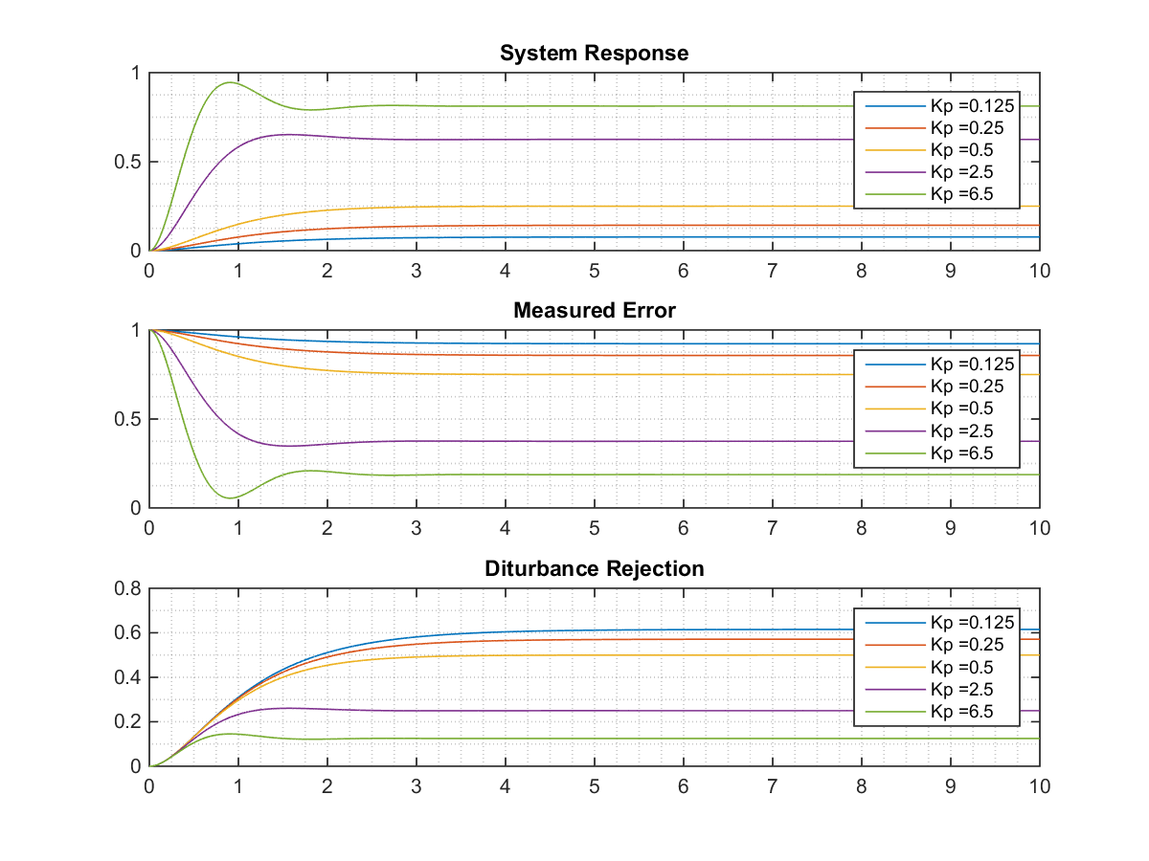

Figure 1.2. Parameters response for Proportional Controller with different values of proportional Kp.

1. The following figures represents the system response using a Proportional Controller with different gain values and no system input, using disturbance as unit step. These figures were obtained using a MATLAB routine, found in Appendix A.

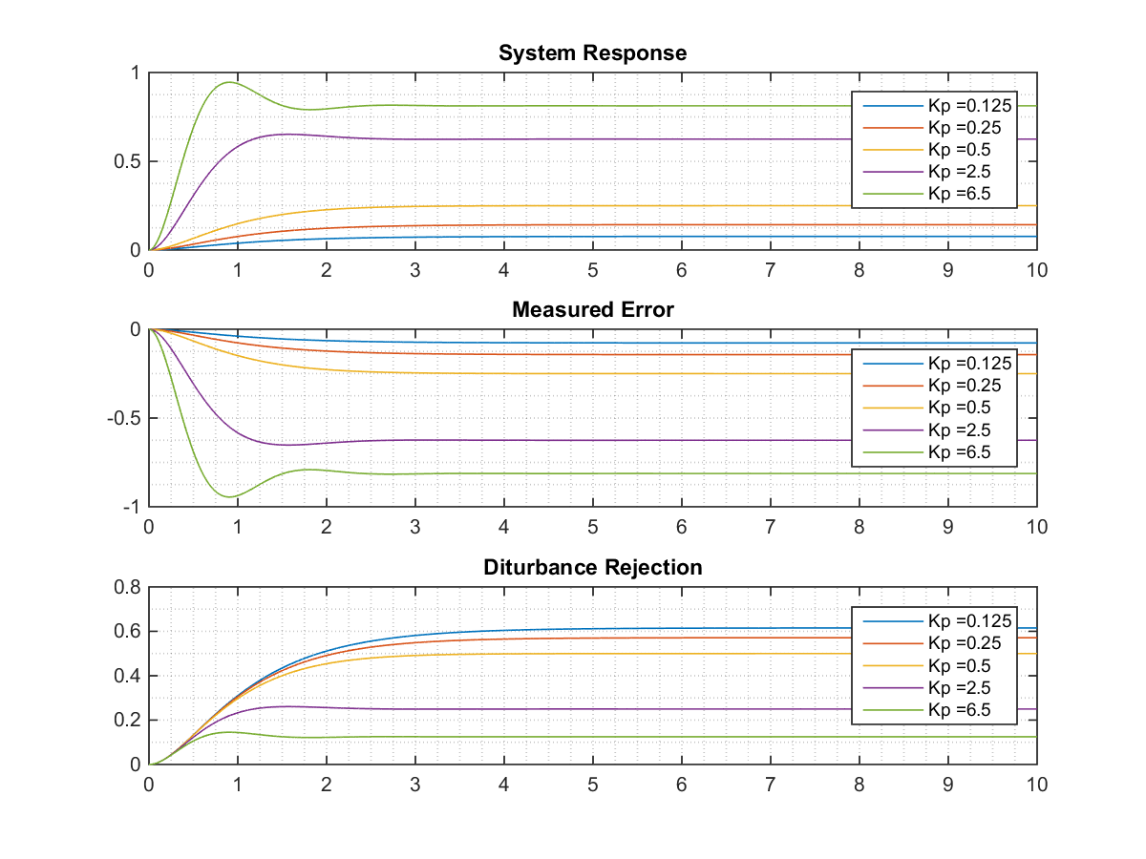

Figure 1.3. Parameters response for Proportional Controller with different values of proportional gain Kp.

1. **Integral Controllers**
2. Simulink model to control the plant by Integral Controller.

The Transfer Function for the Integral Controller is defined as:

$$G_{i}\left(s\right)=\frac{Ki}{s}$$

The Simulink model used to simulate the Plant controlled by an Integral Controller is presented in the next figure:

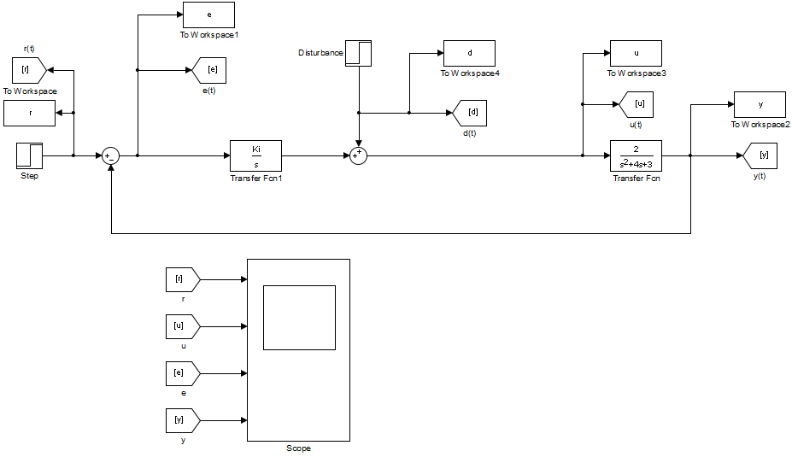

Figure 2.1. Simulink model for plant controlled by Integral Controller.

1. The following figure presents the System Response for different values of the integral controller gain, no disturbance and system input as unit step. These figures were obtained using a MATLAB routine, found in Appendix B.

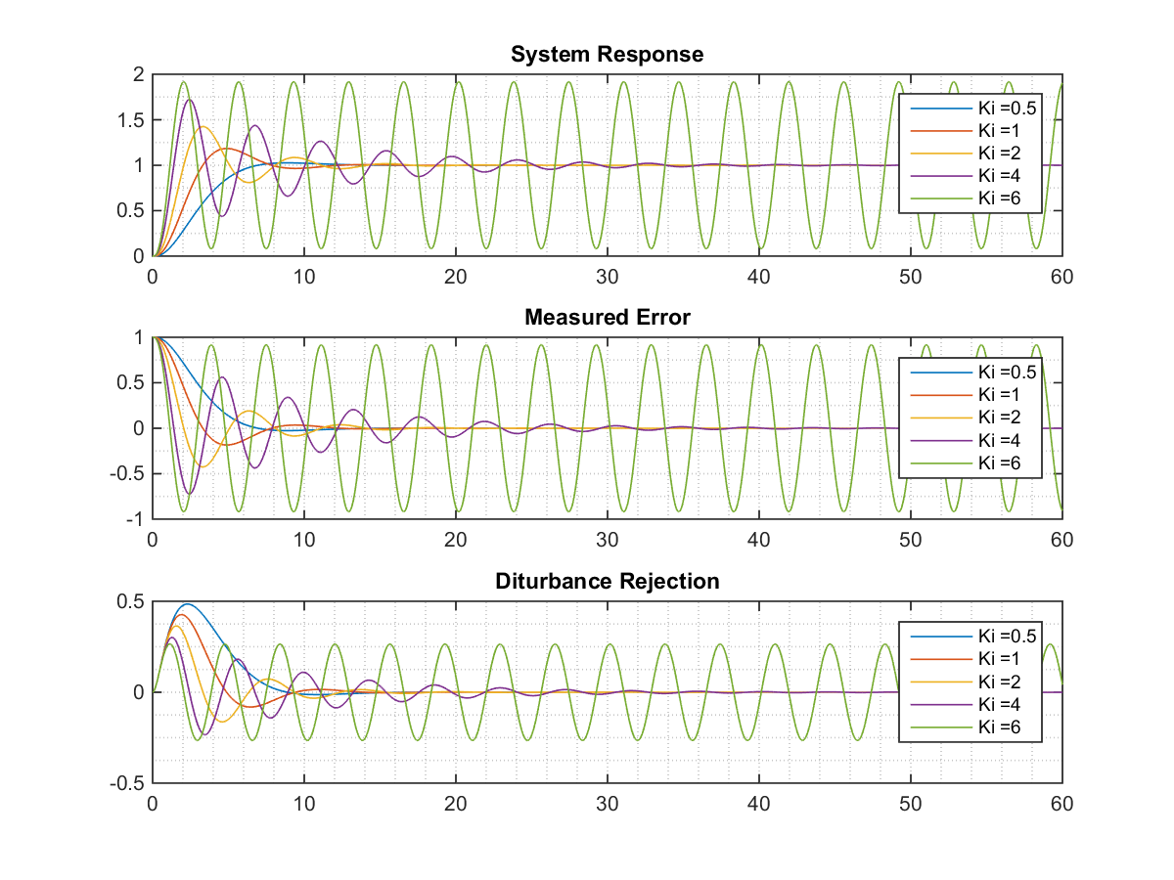

Figure 2.2. Parameters response for Integral Controller for different values of integral gain.

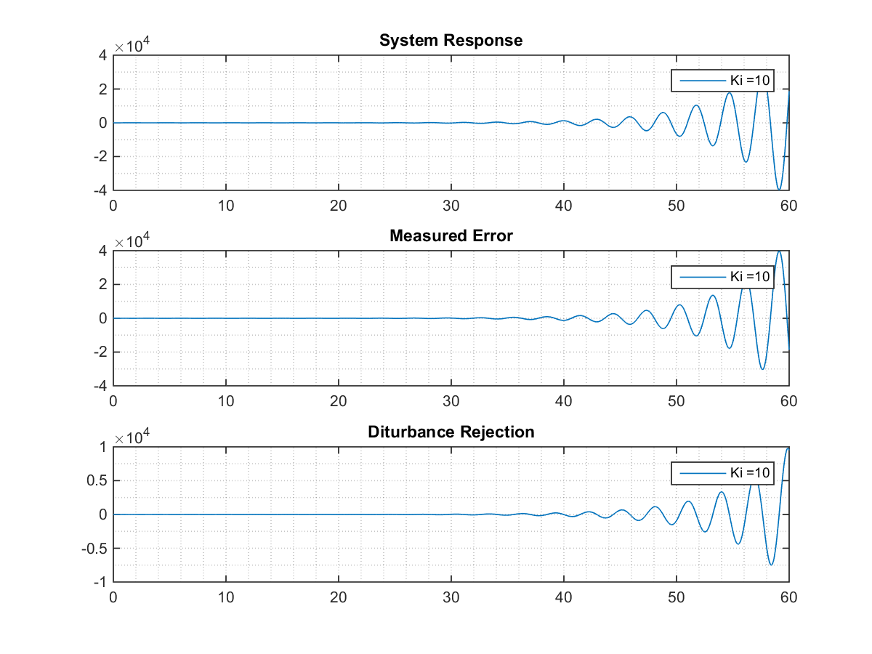

Figure 2.3. Parameters response for Integral Controller with Ki = 10.

1. The following figure presents the System Response for different values of the integral controller gain, no system input and system disturbance as unit step. These figures were obtained using a MATLAB routine, found in Appendix B.

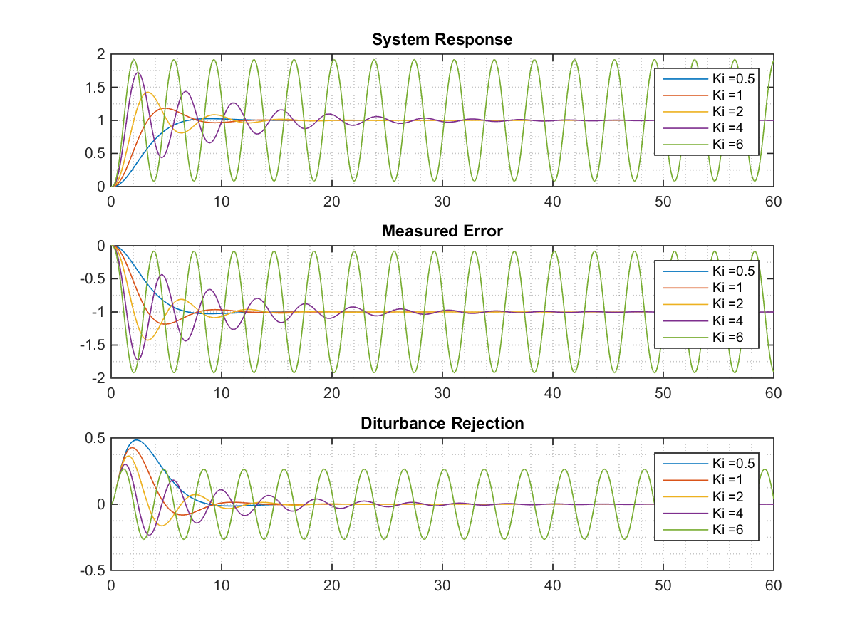

Figure 2.8. Parameters response for Integral Controller with Ki = 0.5.

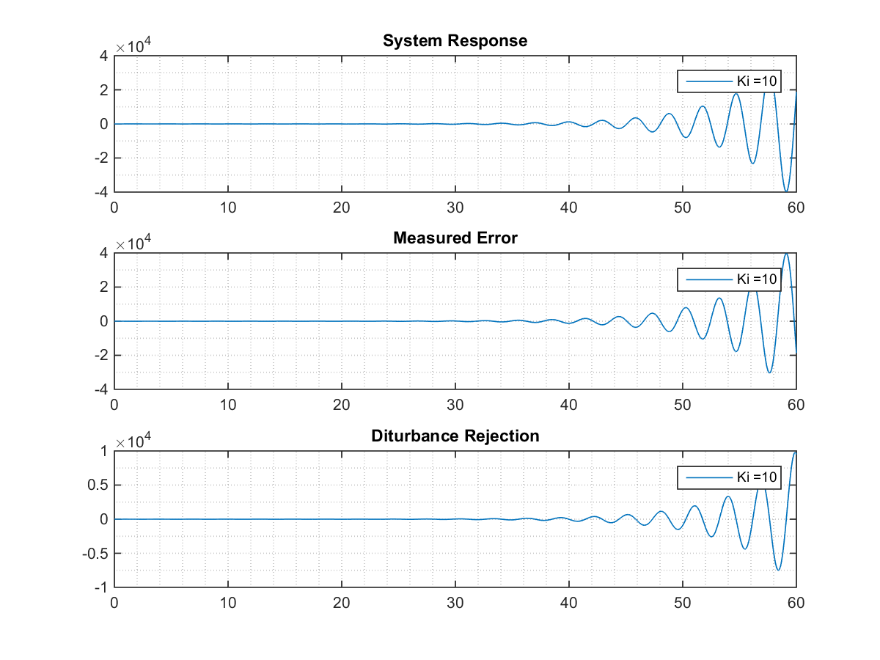

Figure 2.9. Parameters response for Integral Controller with Ki = 1.

1. **Proportional and Integral Controller.**
2. Simulink model to control the plant by using a Proportional Integral Controller.

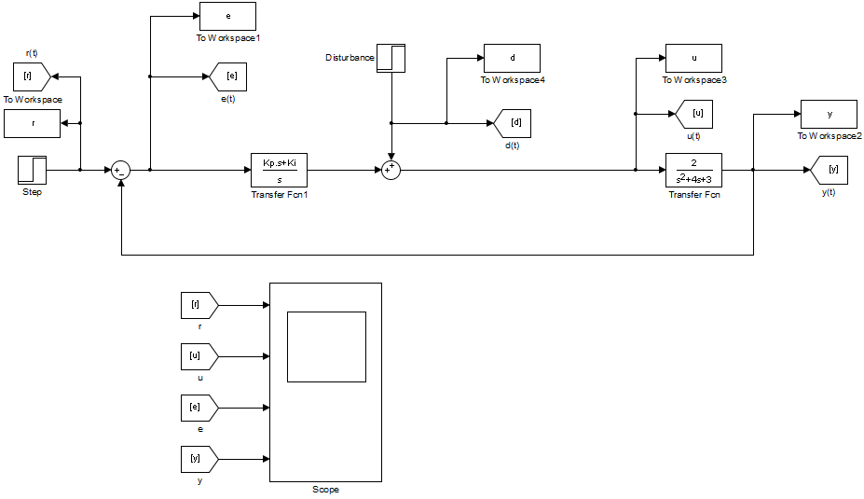

Figure 3.1. Simulink model for plant controlled by Proportional Integral Controller.

The transfer function defined by a proportional integral controlled used in the Simulink model is expressed as:

$$G_{PI}\left(s\right)=Kp+\frac{Ki}{s}=\frac{Kp*s+Ki}{s}$$

Where $Kp$ and $Ki$ are the proportional and integral gains respectively.

1. The following figures present the plant response for different values of $Kp$ and $Ki$, with no disturbance and system input as unit step. These figures were obtained using a MATLAB routine, found in Appendix C.

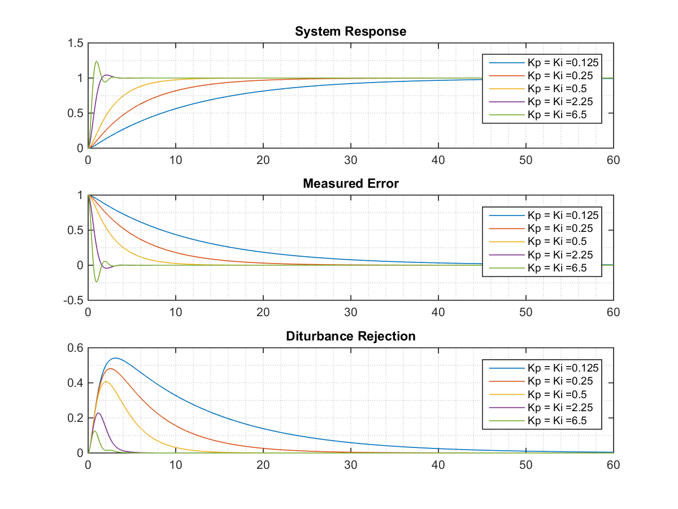

Figure 3.2. Parameters response for Proportional Integral Controller with Ki = 0.125.

1. The following figures present the plant response for different values of $Kp$ and $Ki$, with no system input and system disturbance as unit step. These figures were obtained using a MATLAB routine, found in Appendix C.

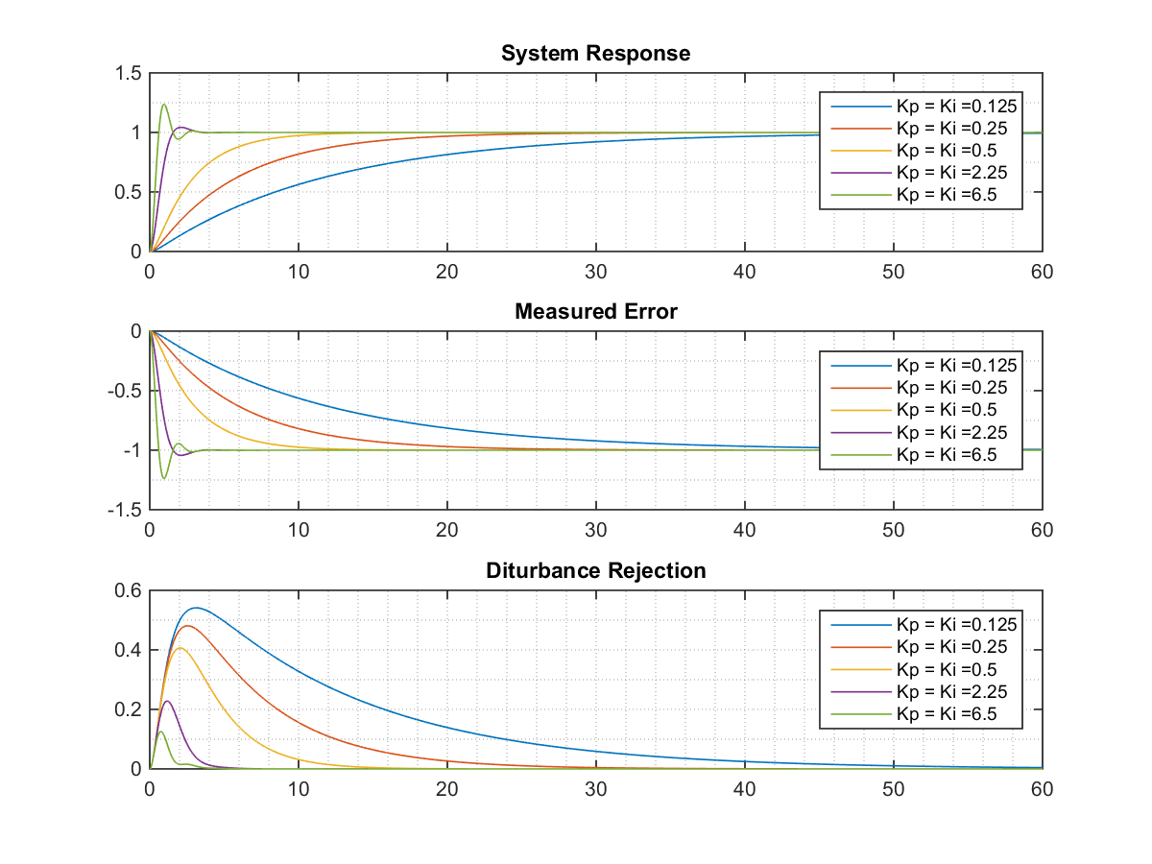

Figure 3.7. Parameters response for Proportional Integral Controller with Ki = 0.125.

**ANALYSIS**

For the responses obtained in Part 2, it is required to obtain some system parameters such as steady-state error ($e(t=∞))$, rise time ($t_{r})$, peak time ( $t_{p})$ percent overshoot ($\%PO)$, settling time ( $t_{s})$ and steady-state value ($y(t=∞))$.

* Proportional Controller

Table 1. Parameters for Proportional Controller with no disturbance and unit step input.

|  |  |  |  |  |  |
| --- | --- | --- | --- | --- | --- |
| $$Kp$$ | $$e(t=∞)$$ | $$t_{r}(s)$$ | $$\%PO$$ | $$t_{s}(s)$$ | $$y(t=∞)$$ |
| 0.125 | 0.9231 | 2.1692 | - | 3.8936 | 0.0768 |
| 0.25 | 0.8571 | 1.9807 | - | 3.5256 | 0.143 |
| 0.5 | 0.75 | 1.6790 | - | 2.9170 | 0.25 |
| 2.5 | 0.375 | 0.7597 | 4.3210 | 2.1082 | 0.625 |
| 6.5 | 0.1875 | 0.4098 | 16.2929 | 2.0190 | 0.815 |

For system with no input and disturbance as step input, as viewed from Figure XX, the response is the same. However, the only parameter changing is the steady-state error, which now will be the same as the negative of the steady-state output value.

Table 2. Parameters for Proportional Controller with no input and unit step disturbance.

|  |  |  |  |  |  |
| --- | --- | --- | --- | --- | --- |
| $$Kp$$ | $$e(t=∞)$$ | $$t_{r}(s)$$ | $$\%PO$$ | $$t_{s}(s)$$ | $$y(t=∞)$$ |
| 0.125 | -0.07692 | 2.1692 | - | 3.8936 | 0.07692 |
| 0.25 | -0.1429 | 1.9807 | - | 3.5256 | 0.1429 |
| 0.5 | -0.25 | 1.6790 | - | 2.9170 | 0.25 |
| 2.5 | -0.625 | 0.7597 | 4.3210 | 2.1082 | 0.625 |
| 6.5 | -0.8125 | 0.4098 | 16.2929 | 2.0190 | 0.8125 |

From Table 1 and 2, it can be seen that for each proportional gain, the system response is the same. However, for some values the response is faster than others, and the system reaches a steady-state closer to the reference. For higher values of gain, the system response steady-state get closer to the reference and the settling time is decreased. However, there is now an overshoot which in some cases can affect the system negatively.

For the proportional controller, the error never becomes zero. This negatively affects the system because the steady-state value does not reach the reference and therefore the expected response is not obtained. On the other hand, it can be seen in Figures 1.2 and 1.3 that the system does not respond positively to the disturbance, because in the ideal case this value should be zero, as happens with other controllers later on.

* Integral Controller

Table 3. Parameters for Integral Controller with no disturbance and unit step input.

|  |  |  |  |  |  |
| --- | --- | --- | --- | --- | --- |
| $$Ki$$ | $$e(t=∞)$$ | $$t_{r}(s)$$ | $$\%PO$$ | $$t_{s}(s)$$ | $$y(t=∞)$$ |
| 0.5 | 0 | 4.1645 | 2.6077 | 10.3891 | 1 |
| 1 | 0 | 2.0996 | 18.4138 | 10.8921 | 1 |
| 2 | 0 | 1.2594 | 42.5147 | 13.4219 | 1 |
| 4 | 0 | 0.8219 | 72.3213 | 32.9506 | 1 |
| 6 | - | - | - | $$∞$$ | - |
| 10 | - | - | - | $$∞$$ | - |

Table 4. Parameters for Integral Controller with no input and unit step disturbance.

|  |  |  |  |  |  |
| --- | --- | --- | --- | --- | --- |
| $$Ki$$ | $$e(t=∞)$$ | $$t_{r}(s)$$ | $$\%PO$$ | $$t_{s}(s)$$ | $$y(t=∞)$$ |
| 0.5 | -1 | 4.1645 | 2.6077 | 10.3891 | 1 |
| 1 | -1 | 2.0996 | 18.4138 | 10.8921 | 1 |
| 2 | -1 | 1.2594 | 42.5147 | 13.4219 | 1 |
| 4 | -1 | 0.8219 | 72.3213 | 32.9506 | 1 |
| 6 | - | - | - | $$∞$$ | - |
| 10 | - | - | - | $$∞$$ | - |

When using an integral controller, the main feature is that there is no steady-state error in any case. For all the integral gains tested, the system response always attaches to the reference so the error becomes zero, knowing that the error is defined as:

$$e\left(t\right)=u\left(t\right)-y(t)$$

However, when using an integral controller, it needs to be tuned correctly. As seen for gains of 6 and 10 (Figure 2.2 and 2.3) the system becomes marginally stable (oscillates infinitely) or becomes instable (the system presents increasing oscillations and never decays).

Finally, it can be seen that the response of the integral controller keeps the error at zero, which indicates that in response to disturbances, the response will minimize the effect of the disturbance until the system is stabilized again in the reference. This process can be observed in Figures 2.2 and 2.3, as long as the controller is perfectly tuned and the response is not marginally stable or unstable.

* Proportional Integral Controller

Table 5. Parameters for Proportional Integral Controller with no disturbance and unit step input.

|  |  |  |  |  |  |  |
| --- | --- | --- | --- | --- | --- | --- |
| $$Kp$$ | $$Ki$$ | $$e(t=∞)$$ | $$t_{r}(s)$$ | $$\%PO$$ | $$t_{s}(s)$$ | $$y(t=∞)$$ |
| 0.125 | 0.125 | 0 | 25.6193 | - | 45.9531 | 1 |
| 0.25 | 0.25 | 0 | 12.4347 | - | 22.4535 | 1 |
| 0.5 | 0.5 | 0 | 5.8584 | - | 10.6547 | 1 |
| 2.5 | 2.5 | 0 | 0.9127 | 5.8316 | 2.6881 | 1 |
| 6.5 | 6.5 | 0 | 0.4137 | 23.7512 | 2.3303 | 1 |

Table 6. Parameters for Proportional Integral Controller with no disturbance and unit step input.

|  |  |  |  |  |  |  |
| --- | --- | --- | --- | --- | --- | --- |
| $$Kp$$ | $$Ki$$ | $$e(t=∞)$$ | $$t_{r}(s)$$ | $$\%PO$$ | $$t_{s}(s)$$ | $$y(t=∞)$$ |
| 0.125 | 0.125 | -1 | 25.6193 | - | 45.9531 | 1 |
| 0.25 | 0.25 | -1 | 12.4347 | - | 22.4535 | 1 |
| 0.5 | 0.5 | -1 | 5.8584 | - | 10.6547 | 1 |
| 2.5 | 2.5 | -1 | 0.9127 | 5.8316 | 2.6881 | 1 |
| 6.5 | 6.5 | -1 | 0.4137 | 23.7512 | 2.3303 | 1 |

The integral proportional controller seems to offer the ideal response to the plant studied in this work, as can be seen in figures 3.2 and 3.3. Using this controller, the system always adheres to the reference and the error always becomes zero. On the other hand, it can be observed that it is ideal at the moment of a disturbance since it always minimizes its effect.

In addition, this controller always offers a stable response to the system. However, this can clearly vary stabilization times, as can be seen in Tables 5 and 6. In addition, although the response is stable for any gain, there will be negative effects such as increases in overshoots, but these will not be as pronounced as in the case of the purely integral controller where the overshoot reached a value of up to 72%.

**CONCLUSION**

In this work we studied the time response of a plant when it is controlled by three different controllers: Proportional Controller, Integral Controller and Proportional Integral Controller. In the presented results it is determined that the ideal controller is the Integral Proportional Controller, which offers a stable response in all the tests carried out, besides guaranteeing an error equal to zero and a satisfactory response to disturbances. The proportional controller is the least indicated for the plant studied since for none of the selected values ​​it presented an output equal to the reference, which is what is sought in the temporary response of a plant. In addition, due to this the error is always different from zero and the response to disturbances is unfavorable since it does not minimize the effect of said disturbance.

The second controller studied was the integral controller. This controller presented an ideal response for the plant since it guaranteed an equal response to the reference and an error equal to zero, in addition to minimizing the effects of the disturbances. However, it should be ideally tuned since otherwise the response may be marginally stable or totally unstable, as can be seen in figures 2.2, 2.3, 2.4 and 2.5.

The proportional integral controller seems to be the indicated controller. In addition to offering stability for the selected gains, it guarantees an error equal to zero and a minimum response to disturbances. Clearly the parameters of tuning will depend on the plant to be controlled and in this work, it is not possible to deduce the ideal gain values ​​since the characteristics of the plant should be known in more detail, since for some plants it may not be affected due to a very high overshoot, or a large stabilization time, while for others it may be the opposite.

For future work, it is proposed to carry out the study by adding the derivative part of the PID controller and analyze the responses for different values.

**APPENDIX A**

clc, clear all, close all

%% Question 1: Using TF

Kpv = [0.125 0.25 0.5 2.5 6.5];

plegend = cell(length(Kpv), 1);

for i = 1:length(Kpv)

plegend{i} = strcat('Kp = ', num2str(Kpv(i)));

end

s = tf('s');

G = 2/(s^2 + 4*s + 3);

u = 1; % step input. Set to zero for the case where there is only disturbance

tspan = 0:1e-3:60; % we will show the response for 60 seconds

figure(1)

for i = 1:length(Kpv)

Ki = 0;

Kp = Kpv(i);

Gc = Kp + Ki/s;

Gsys = feedback(Gc*G, 1);

Gdr = feedback(G, Gc);

[y,t] = step(Gsys, tspan);

error = u - y;

[y2,t2] = step(Gdr, tspan);

subplot(3,1,1)

plot(t, y), hold on

grid minor

legend(plegend)

title('System Response')

subplot(3,1,2)

plot(t, error), hold on

grid minor

title('Measured Error')

legend(plegend)

subplot(3,1,3)

plot(t2, y2), hold on

title('Diturbance Rejection')

legend(plegend)

grid minor

end

stepinfo(Gsys)

**APPENDIX B**

clc, clear all, close all

%% Question 2: Response By TF

Kiv = [0.5 1 2 4 6]; % Plot for Ki = 10 is apart

plegend = cell(length(Kiv), 1);

for i = 1:length(Kiv)

plegend{i} = strcat('Ki = ', num2str(Kiv(i)));

end

s = tf('s');

G = 2/(s^2 + 4*s + 3);

u = 1; % step input. Set to zero for the case where there is only disturbance

tspan = 0:1e-3:60; % we will show the response for 60 seconds

figure(1)

for i = 1:length(Kiv)

Ki = Kiv(i);

Kp = 0;

Gc = Kp + Ki/s;

Gsys = feedback(Gc*G, 1);

Gdr = feedback(G, Gc);

[y,t] = step(Gsys, tspan);

error = u - y;

[y2,t2] = step(Gdr, tspan);

subplot(3,1,1)

plot(t, y), hold on

grid minor

legend(plegend)

title('System Response')

subplot(3,1,2)

plot(t, error), hold on

grid minor

title('Measured Error')

legend(plegend)

subplot(3,1,3)

plot(t2, y2), hold on

title('Diturbance Rejection')

legend(plegend)

grid minor

end

stepinfo(Gsys)

% The response for Ki = 10 is apart since the response is unstable

Ki = 10;

Gc = Ki/s;

Gsys = feedback(G*Gc, 1);

Gdr = feedback(Gsys,Gc);

[y, t] = step(Gsys, tspan);

[y2, t2] = step(Gdr, tspan);

error = u - y;

figure(2);

subplot(3,1,1)

plot(t, y), hold on

grid minor

legend('Ki = 10');

title('System Response')

subplot(3,1,2)

plot(t, error), hold on

grid minor

legend('Ki = 10');

title('Measured Error')

subplot(3,1,3)

plot(t2, y2), hold on

grid minor

legend('Ki = 10');

title('Disturbance Rejection')

**APPENDIX C**

clc, clear all, close all

%% Question 3: Response By TF

Kiv = [0.125 0.25 0.5 2.5 6.5];

plegend = cell(length(Kiv), 1);

for i = 1:length(Kiv)

plegend{i} = strcat('Kp = Ki = ', num2str(Kiv(i)));

end

s = tf('s');

G = 2/(s^2 + 4*s + 3);

u = 1; % step input. Set to zero for the case where there is only disturbance

tspan = 0:1e-3:60; % we will show the response for 60 seconds

figure(1)

for i = 1:length(Kiv)

Ki = Kiv(i);

Kp = Ki;

Gc = Kp + Ki/s;

Gsys = feedback(Gc*G, 1);

Gdr = feedback(G, Gc);

[y,t] = step(Gsys, tspan);

error = u - y;

[y2,t2] = step(Gdr, tspan);

subplot(3,1,1)

plot(t, y), hold on

grid minor

legend(plegend)

title('System Response')

subplot(3,1,2)

plot(t, error), hold on

grid minor

title('Measured Error')

legend(plegend)

subplot(3,1,3)

plot(t2, y2), hold on

title('Diturbance Rejection')

legend(plegend)

grid minor

end

stepinfo(Gsys)

%% Each plot separately